Name : Mutayyab Imran

Enrollnment # : 02-131212-063

Registration # : 79315

Subject : Data Structures & Algorithms

**Question # 1:** Describe RAM and ROM

**Solution**:

**RAM**

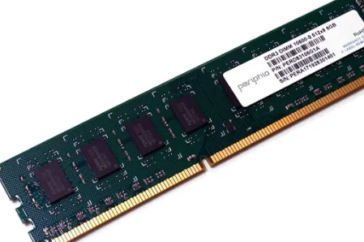RAM is volatile memory, which means that the information temporarily stored in the module is erased when you restart or shut down your computer. Because the information is stored electrically on transistors, when there is no electric current, the data disappears. Each time you request a file or information, it is retrieved either from the computer's storage disk or the internet. The data is stored in RAM, so each time you switch from one program or page to another, the information is instantly available. When the computer is shut down, the memory is cleared until the process begins again. Volatile memory can be changed, upgraded, or expanded easily by users.

**ROM**

ROM stands for non-volatile memory in computers., which means the information is permanently stored on the chip. The memory does not depend on an electric current to save data, instead, data is written to individual cells using binary code. Non-volatile memory is used for parts of the computer that do not change, such as the initial boot-up portion of the software, or the firmware instructions that make your printer run. Turning off the computer does not have any effect on ROM. Non-volatile memory cannot be changed by users.

|  |  |  |
| --- | --- | --- |
| Difference | RAM | ROM |
| Data retention | RAM is a volatile memory which could store the data as long as the power is supplied. | ROM is a non-volatile memory which could retain the data even when power is turned off. |
| Working type | Data stored in RAM can be retrieved and altered. | Data stored in ROM can only be read. |
| Use | Used to store the data that has to be currently processed by CPU temporarily. | It stores the instructions required during bootstrap of the computer. |
| Speed | It is a high-speed memory. | It is much slower than the RAM. |
| CPU Interaction | The CPU can access the data stored on it. | The CPU can not access the data stored on it unless the data is stored in RAM. |
| Size and Capacity | Large size with higher capacity, with respect to ROM | Small size with less capacity, with respect to RAM |
| Used as/in | CPU Cache, Primary memory. | Firmware, Micro-controllers |
| Accessibility | The data stored is easily accessible | The data stored is not as easily accessible as in RAM |
| Cost | Costlier | cheaper than RAM. |
| Storage | A RAM chip can store only a few gigabytes (GB) of data. | A ROM chip can store multiple megabytes (MB) of data. |

**Question # 2:** Define DRAM and SRAM and state their differences.

**Solution**:

## DRAM

Data is stored in capacitors. Capacitors that store data in DRAM gradually discharge energy, no energy means the data has been lost. So, a periodic refresh of power is required in order to function. DRAM is called dynamic as constant change or action(change is continuously happening) i.e. refreshing is needed to keep the data intact. It is used to implement main memory.

**Advantage*:***Low costs of manufacturing and greater memory capacities*.***Disadvantage*:***Slowaccess speed and high power consumption.

## SRAM

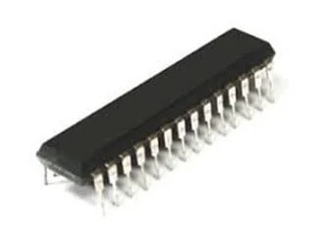Data is stored in transistors and requires a constant power flow. Because of the continuous power, SRAM doesn’t need to be refreshed to remember the data being stored. SRAM is called static as no change or action i.e. refreshing is not needed to keep the data intact. It is used in cache memories.

**Advantage*:***Low power consumption and faster access peeds.   
**Disadvantage*:***Fewer memory capacities and high costs of manufacturing.

|  |  |
| --- | --- |
| SRAM | DRAM |
| SRAM has lower access time, which is faster compared to DRAM. | DRAM has a higher access time. It is slower than SRAM. |
| SRAM is costlier than DRAM. | DRAM cost is lesser compared to SRAM. |
| SRAM needs a constant power supply, but it consumes less power. | DRAM requires more power consumption as the information is stored in the capacitor. |
| Uses transistors and latches. | Uses capacitors and very few transistors. |
| L2 and L3 CPU cache units are some general application of an SRAM. | The DRAM is mostly found as the main memory in computers. |
| The storage capacity of SRAM is 1MB to 16MB. | The storage capacity of DRAM is 1 GB to 16GB. |
| SRAM is in the form of on-chip memory. | DRAM has the characteristics of off-chip memory. |
| The SRAM is widely used on the processor or lodged between the main memory and processor of your computer. | The DRAM is placed on the motherboard. |
| SRAM is of a smaller size. | DRAM is available in larger storage capacity. |
| This type of RAM works on the principle of changing the direction of current through switches. | This type of RAM works on holding the charges. |

**Question # 3:** Define and state the differences among PROM, EPROM, EEPROM

**Solution**:

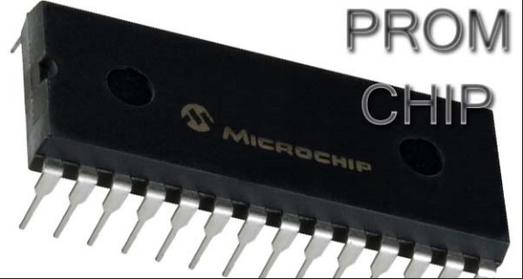**PROM**PROM stands for **Programmable Read Only Memory**. It is a computer memory chip, and it is possible to program it once after creation. After programming the PROM, the information we write to it becomes permanent. Therefore, we cannot erase or delete that written data.  The PROM chip was commonly used in earlier computers’ [BIOS](http://pediaa.com/difference-between-bios-and-cmos/#BIOS)systems.

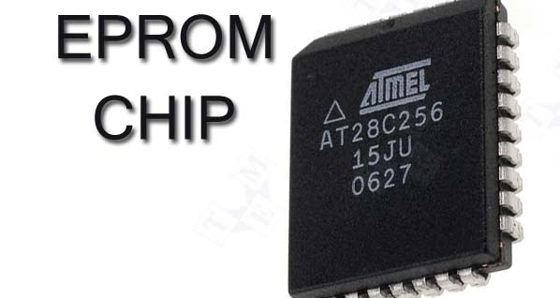**EPROM**EPROM stands for **Erasable Programmable Read Only Memory**. We can erase and reprogram an EPROM without replacing it. It is possible to erase and write to it by exposing the memory chip to ultraviolet light. Moreover, it is easier to recognize EPROM via transparent fused quartz window in the top of the package.

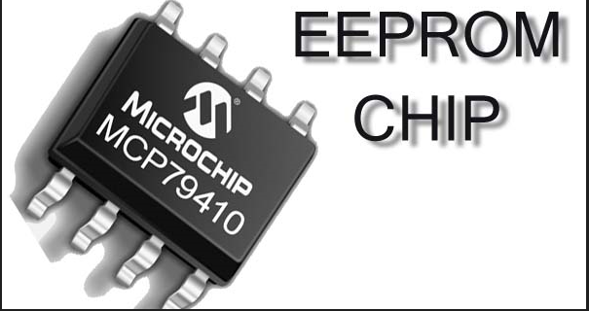**EEPROM**EEPROM stands for **Electrically Erasable Programmable Read-Only Memory**. It is a memory chip that we can erase and reprogram using electrical charge. It consists of a collection of floating gate [transistors](http://pediaa.com/difference-between-transistor-and-thyristor/). The flash memory is a type of EEPROM which has a higher density and lower number of write cycles.

|  |  |  |  |
| --- | --- | --- | --- |
|  | PROM | EPROM | EEROM |
| Abbreviation  (Stands For) | PROM stands for programmable random access memory. | EPROM stands for Erasable programmable random access memory. | EEPROM stands for Electrically Erasable programmable random access memory. |
| Modification | PROM is the type of ROM that can be modified only once by user. | A programmable ROM that can be erased and reused. | A user modified ROM that can be erased and reprogrammed repeatedly through normal electrical voltage. |
| Cost | PROM is not so expensive | It is expensive than PROM | New version of PROM &EPROM |
| Transistors | Used dual transistors. | Used MIOS transistors. | Data can be reset after deletion. |
| Flexibility | More flexible than EPROM. | Less flexible than PROM. | More flexible than PROM &EPROM. |
| Example | PROM example is CD-R. | EPROM example is CD(RW). | EEPROM example is pen drive. |

**Question # 4:** Define SSD and HDD and state their differences.

**Solution**:

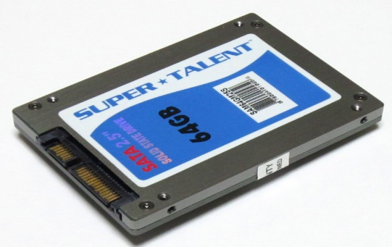**SSD**

Solid State Drive (**SSD**) is a non-volatile storage device that stores and retrieves data constantly on solid-state flash memory. However, this data is stored on interconnected flash memory chips instead of platters, which makes them faster than HDDs. It provides better performance compared to HDD.

**HDD**

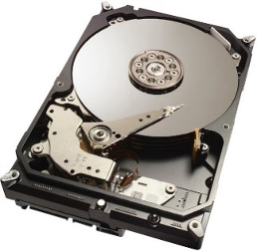An HDD uses magnetism, which allows you to store data on a rotating platter. It has a read/write head that floats above the spinning platter for Reading and Writing of the data. The faster the platter spins, the quicker an HDD can perform. HDD also consists of an I/O controller and firmware, which tells the hardware what to do and communicates with the remaining system. The full form of HDD is Hard Disk Drive

|  |  |  |  |
| --- | --- | --- | --- |
| S. No. | Parameter | HDD | SSD |
| 2. | Components | HDD contains moving mechanical parts, like the arm. | SSD does not contains, mechanical parts, only electronical parts like ICs. |
| 3. | R/W Time | HDD has longer R/W time. | SSD has shorter R/W time.. |
| 4. | Latency | HDD has higher latency. | SSD has lower latency. |
| 5. | I/O operations per second | HDD supports fewer I/O operations per second. | SSD supports more I/O operations per second. |
| 6. | Fragmentation | HDD has fragmentation. | SSD does not have fragmentation. |
| 7. | Weight | HDD is heavier in weight. | SSD is lighter in weight. |
| 8. | Size | HDD is larger in size. | SSD is more compact in size. |
| 9. | Data Transfer | In HDD the data transfer is sequential. | In SSD the data transfer is random access. |
| 10. | Reliability | HDD is less reliable due to possibility of mechanical failure, like head crash and susceptibility to strong magnets. | SSD is more reliable. |
| 11. | Cost | HDD is cheaper per unit storage. | SSD is costlier per unit storage. |
| 13. | Noise | HDD can produce noise due to mechanical movements. | SSD does not produces noise. |
| 14. | Availability | The availability of HDD in a variety of capacities. | The availability of SSD is limited in terms of variety of storage capacities as compared to HDD. |
| 15. | Breakdown | It is more likely to breakdown after more uses because of the magnetic platters and moving mechanical parts. | It is less likely to breakdown as compared to HDD because of no moving parts. |
| 18. | Access speed | The data accessing speed is slower as compared to SSD. | The data accessing speed is much higher as compared to HDD. |